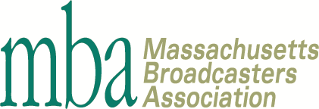

Broadcaster of the Year Nomination Form
Nominate a broadcaster for the Massachusetts Broadcasters Association’s Broadcaster of the Year award to be presented at Sound Bites 2022!
If you know an industry leader in radio or TV that displays an outstanding commitment to his/her job while showing an unwavering dedication to the evolution of broadcasting, nominate him or her for Broadcaster of the Year!
This award can honor anyone in the industry that is committed to providing live and local content to their community. From programmers and engineers to on-air personalities, account executives and general managers there is surely someone at your station that deserves to be recognized!
Fill out the following form to the best of your ability and email a copy to the MBA office at jordan@massbroadcasters.org to nominate a broadcaster today!
THESE NOMINATIONS ARE FREE
About You

Your name: Company:

Email: Phone number:

About Your Nominee (attach additional pages or materials if necessary)

Name: Company:

Call letters: Position:

Station GM: Years in Broadcasting:
Awards and achievements:

<continues on next page>

Tell us about your nominee’s history in broadcasting:

Why do you feel your nominee deserves to be named the Massachusetts Broadcasters Association’s Broadcasters of the Year?

What has your nominee done to better his/her community?

What else would you like to share about your nominee?

Email your nomination form to jordan@massbroadcasters.org by August 19. Thank you!

